**Can you explain different types of exceptions in java or Exception Hierarchy in java**

All exception and error types are subclasses of the **Throwable** class, which is the base class of the hierarchy.

In Java, there are two types of exceptions:

1. Checked exceptions
2. Unchecked exceptions

### 1) Checked Exception

Checked exceptions are checked at compile-time by compiler

The classes that directly inherit the Throwable class except Runtime Exception are known as checked exceptions

Examples for checked Exception are

1. IO Exception,
2. File Not Found Exception,
3. Class Not Found Exception
4. Interrupted exception,
5. SQLException

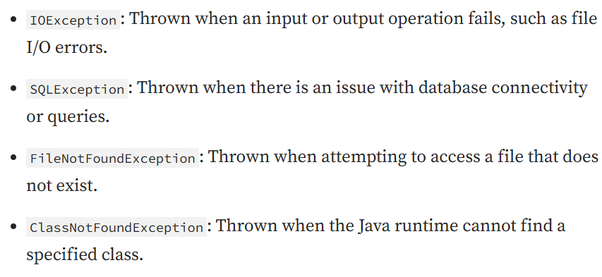

2) Unchecked Exception

Unchecked exceptions happen at runtime during the program executed.

The classes that inherit the Runtime Exception are known as unchecked exceptions.

Examples for unchecked Exception are

* Arithmetic Exception,
* Null Pointer Exception,
* Array Index Out Of Bounds Exception,
* Class cast exception
* Stale Element Exception etc

3) Error

Error is irrecoverable. example of errors are OutOfMemoryError, VirtualMachineError, AssertionError etc. Stack Over flow errors

